Group Member Names: Quinn, Grace, Nicholas,

Course and Quarter: Eng 114 Summer 2017

Date: September 1st

Revision Number: 001

**Light relay (using ThingSpeak)**

**Problem Statement:**

Our group was tasked with improving on what the team last year created. By connecting our MATLAB script with Thinkspeak and allow for an automatic on and off of the light relay coherent with the daily sunrise and sunset schedule.

**Hardware Setup:**

Bill of Materials:

|  |  |  |  |  |
| --- | --- | --- | --- | --- |
| Component | Vendor | Item Description | Item Number | Web Link |
| Redboard | SparkFun | Microcontroller | DEV-13975 | https://www.sparkfun.com/products/13975 |
| Jumper wires x3 | SparkFun | Wires | PRT-10897 | https://www.sparkfun.com/products/10897 |
| USB cable | SparkFun | Connecting device | CAB-11301 | https://www.sparkfun.com/products/11301 |
| Beefcake Relay | SparkFun | Relay | KIT-13815 | https://www.sparkfun.com/products/13815 |
| USB Mini-B Cable | SparkFun | USB Mini-B Cable - 6 Foot | CAB-11301 | https://www.sparkfun.com/products/11301 |

Hardware Schematic. Can be hand drawn and scanned, computer generated, or downloaded from the internet (must include a citation!!!)

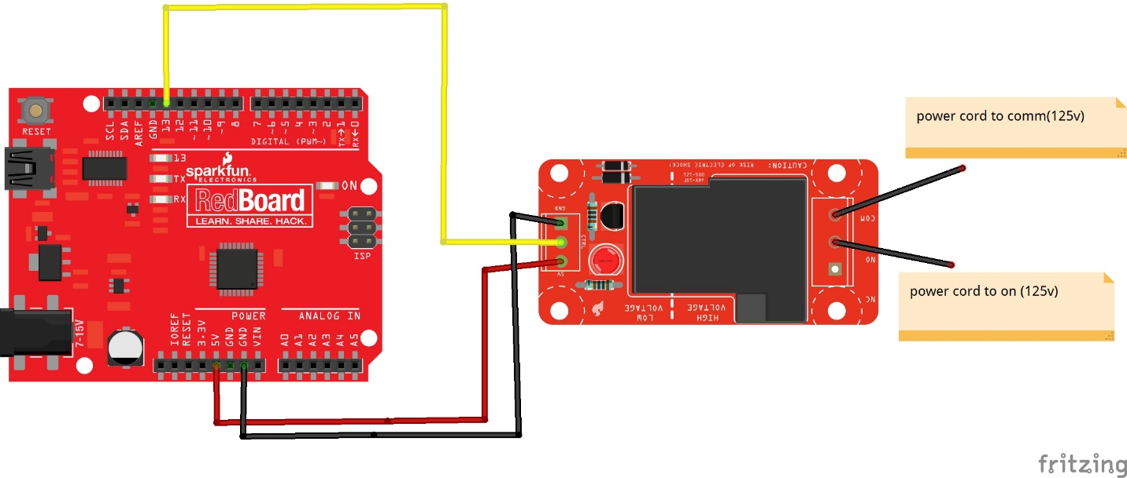

Hookup Guide

First step: Lay out all the components on the relay board following the instruction on previous page (drawn in fritzing)

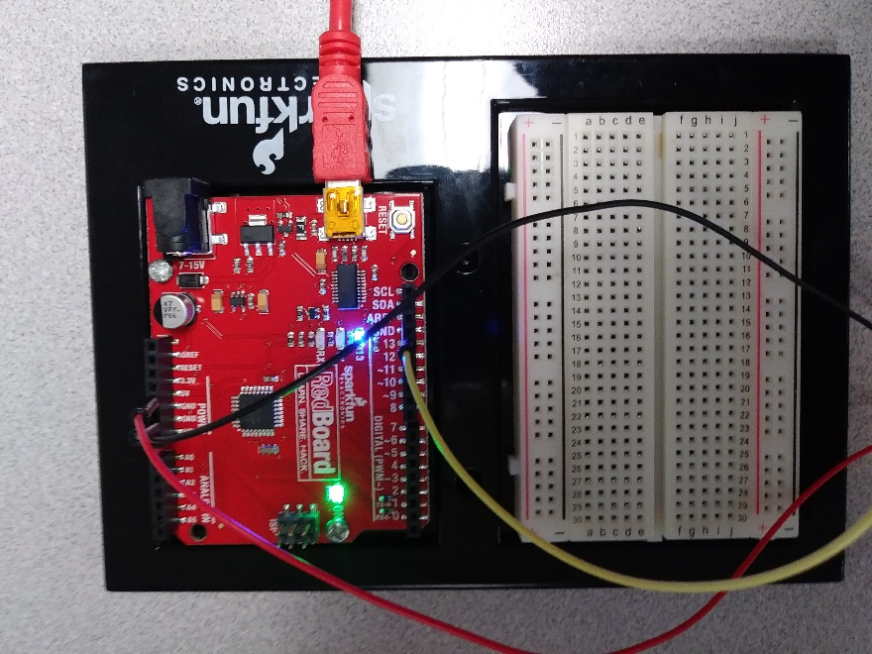

Second step: connect the wires to the controller

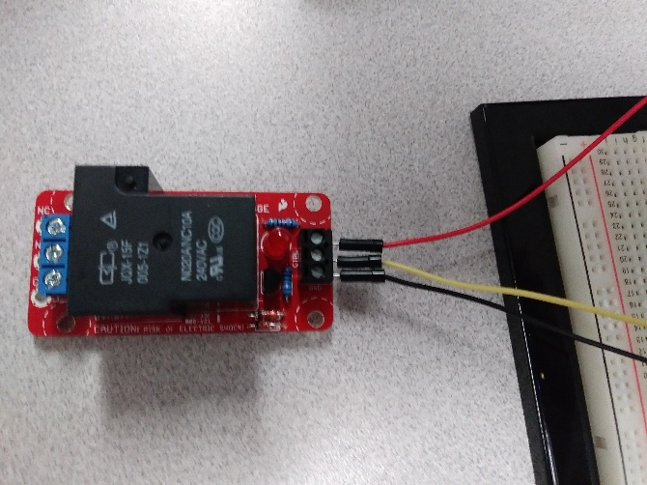

Third step: Prepare the box by drilling two holes on either end for the power cord. Also cut out two access holes for the USB and adapter cables.

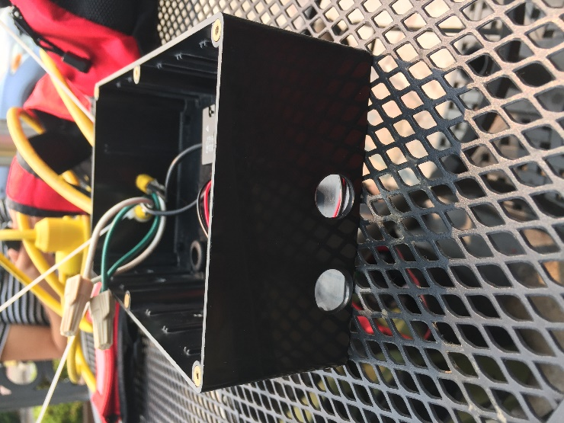

Fourth step: Temporarily install stand-offs on the red board and relay board; use some zip ties to keep things secure in place. Then position inside box with outlets towards previously made cut-outs.

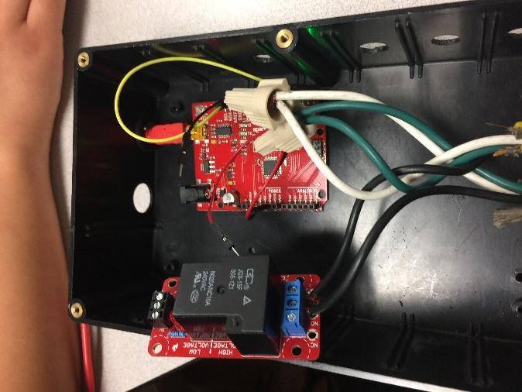

Fifth step: Feed the power cables inside the box. Connect the two white (neutral) wires together and the two green (ground) wires together with wire nuts. Then feed the two black (hot) wires into the blue terminal block (high voltage side) of the relay into the two right-hand most slots (order depends on the code order, but CO - common and NO - normally open are the best options).

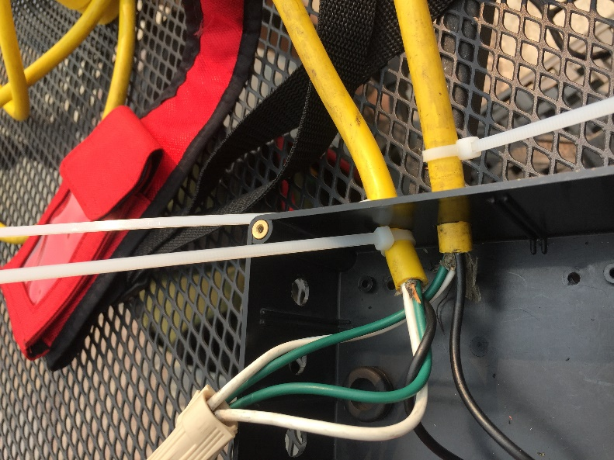

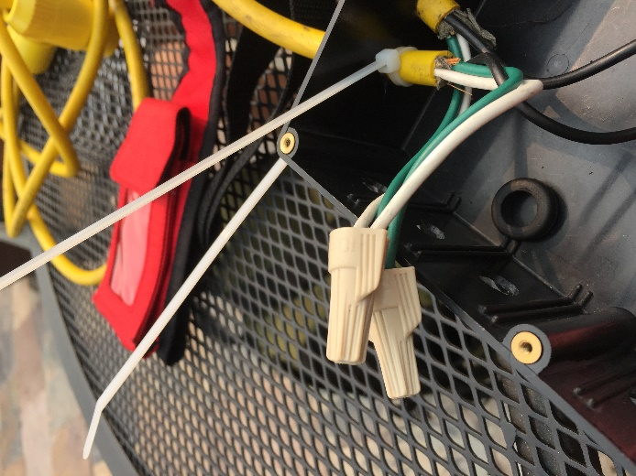

**Code:**

Matlab Code (from a .m file) - format this nicely with .html output. Ensure it contains a header, is sectioned in a logical way is well commented and documented. About one line of comments for each line of code. This should be copied and pasted, not imported as an image which can not be modified.

Arduino Code (from a .ino file) - format this as nicely as you can. Ensure it contains a header and is well commented and documented. About one line of comments for each line of code. This should be copied and pasted, not imported as an image which can not be modified.

**Results:**

Include a picture or a plot. Must have something visual in this section.

**Future Work:**

What could another group of students do to build on this project? Any resources this group could use to build this future work?

**License**

Can be MIT licenses or BSD license. Include if you want to others to acknowledge where the work came from.

\